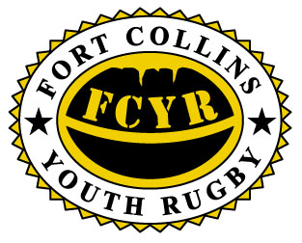
PLAY RUGBY!!!
HIGH SCHOOL BOYS AGES 14-19
ALL PLAYERS WELCOME - POSITIONS FOR EVERYONE NO EXPERIENCE NEEDED
JOIN US ANYTIME!!!!
PRACTICE STARTS Jan 25th
FORT COLLINS HAMMER RUGBY
2015 Division II STATE CHAMPIONS!!!!!
For More Information Contact:
Mitch Bowers 988-7984 email: youth@fortrugby.com
Web Page: http://fortcollinsyouthrugby.org
ENJOY USA FASTEST GROWING SPORT!!!!!!!

